# User Manual

Contents

User Manual 1

Introduction 2

Installation 3

System Requirements 3

Installation Guide 3

Tutorial 4

Getting Started – The Main Menu 4

Create your own model! 5

Practice! 11

Error Messages 16

## Introduction

This aim of this guide is to provide information about the features of the interactive ‘pulley systems on an incline’ modelling software and how to use them. The program is designed to be used by students and teachers of the M1 Mathematics Mechanics module at Merchant Taylors’ School.

The program can be found on the school network in executable format. See installation for more information.

The program is split into two parts:

1. Allows the user to create their own ‘pulley systems on an incline’ M1 model, before seeing it animate based on its configuration.
2. Creates a random ‘pulley systems on an incline’ M1 model, and questions the user on the model.

This guide explains these two parts in greater detail, and explains how to use each feature of the program. It also advises the user on why error messages appear and how to recover from them.

## Installation

### System Requirements

The system has been tested on the following minimum specifications:

|  |  |
| --- | --- |
| **Component** | **Requirement** |
| Processor | 500 MHz or higher |
| Memory | 256 MB of DDR3 RAM or higher |
| Hard Disk | 20 MB of free space for the executable file |
| Display | 1280 x 768 resolution or higher |
| Operating System | Windows XP or later |

### Installation Guide

No specific installation is necessary by the user as the executable is stored on the school network and can be run by all. To access it:

1. Log into the school network.
2. Browse to the applications folder within the file directory.
3. Select the Maths folder.
4. Within the Maths folder, the program’s executable ‘Pulley systems on an incline’ can be found.
5. The program can then be run from this folder by double clicking on the executable file.

## Tutorial

### Getting Started – The Main Menu

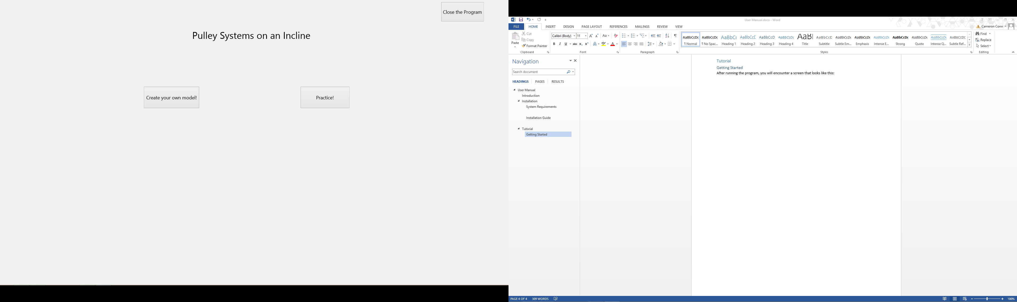On starting the program, a form as shown below is displayed:

This is the Main Menu of the program. There are 3 buttons that can be selected and their funnctionality it expained below:

#### ‘Close the Program’ Button

Clicking on this button will close the program.

‘Create your own model!’ Button

Clicking on this button will display a form where M1 ‘pulley systems on an incline’ models can be created and animated.

‘Practice!’ Button

Clicking on this button will display a form where ‘pulley systems on an incline’ knowledge will be tested by questioning the user on a randomly generated model.

For the purposes of this walkthrough of the entire programs functionality, It is assumed the ‘Create your own model!’ button is used.

### Create your own model!

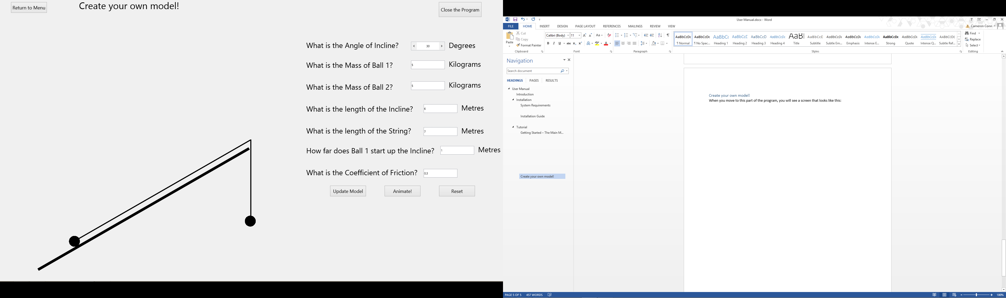When moving to this part of the program, a form shown below is displayed:

Note:

Ball 1



Ball 2

The functionality of this form is five fold.

#### Returning to the Menu

To return to the Main Menu, select the ‘Return to Menu’ button.

#### Close the Program

To close the program, select the ‘Close the program’ button.

#### Updating the model

The ‘Update Model’ button will animate the model on the left side of the screen to the configuration defined by the user. To define the configuration, the user can edit the selectors on the right hand side of the screen:



The model

Selectors the user can edit

As an example, if the selectors are changed to the configuration below:

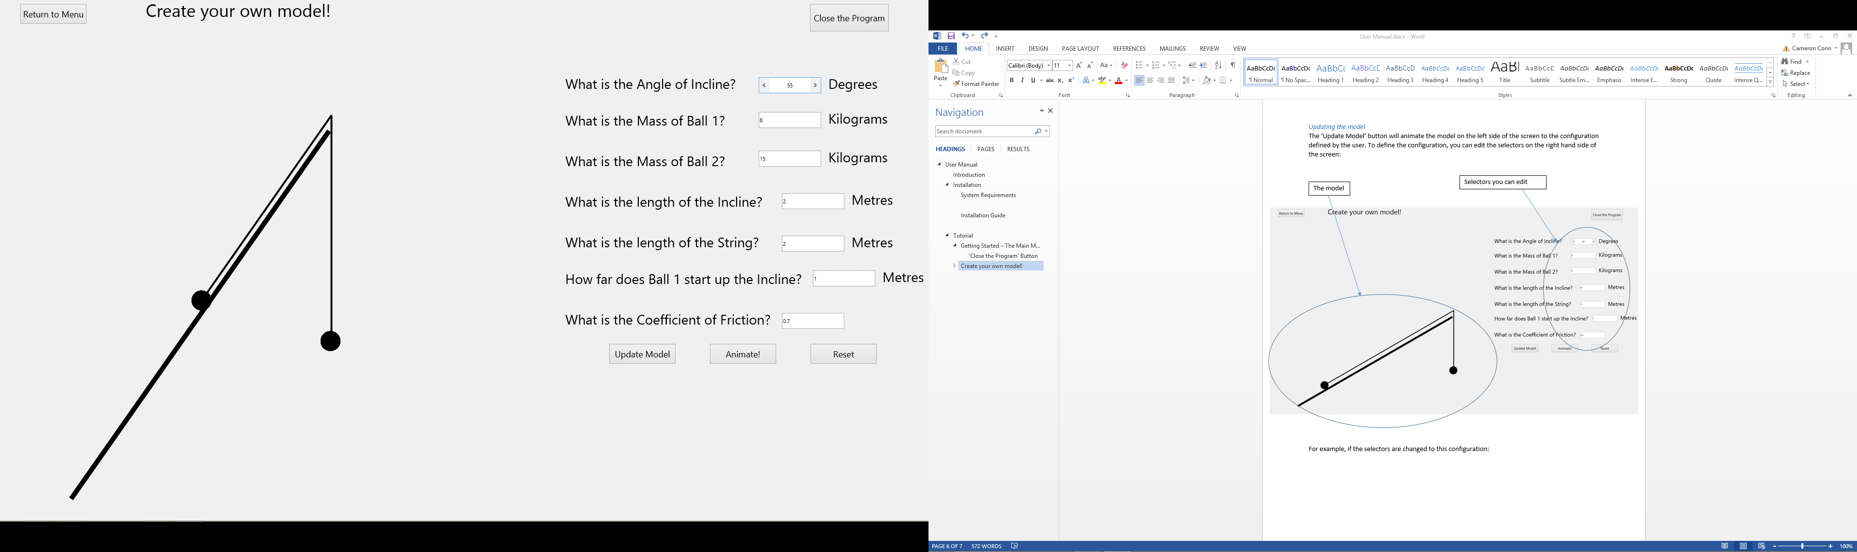

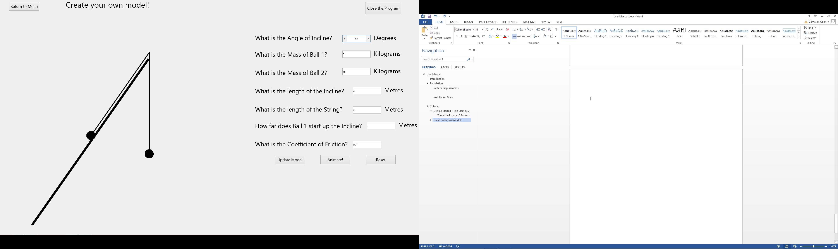And then the ‘Update Model’ button is selected, the model on the left will animate to that user-defined configuration. The new form would look like this:

It is worth noting that the selectors themselves only accept values according to the following rules:

|  |  |
| --- | --- |
| **Selector** | **Rule** |
| Angle of Incline | Integer between 0 and 90 non-inclusive |
| Mass of Ball 1 | 3 digit or less real |
| Mass of Ball 2 | 3 digit or less real |
| Length of the Incline | 3 digit or less real |
| Length of the String | 3 digit or less real |
| How far Ball 1 starts up Incline | 3 digit or less real |
| Coefficient of Friction | 4 digit or less real |

If these rules are broken an error message will be displayed. The specifics of this will be covered later in this User manual in the section ‘error messages’.

#### Animating the model

The ‘Animate!’ button will animate the model on the left side of the screen based on its current configuration. For example, if the button was selected after updating the model to the configuration used in the last section, the model would animate, leaving it in this configuration:

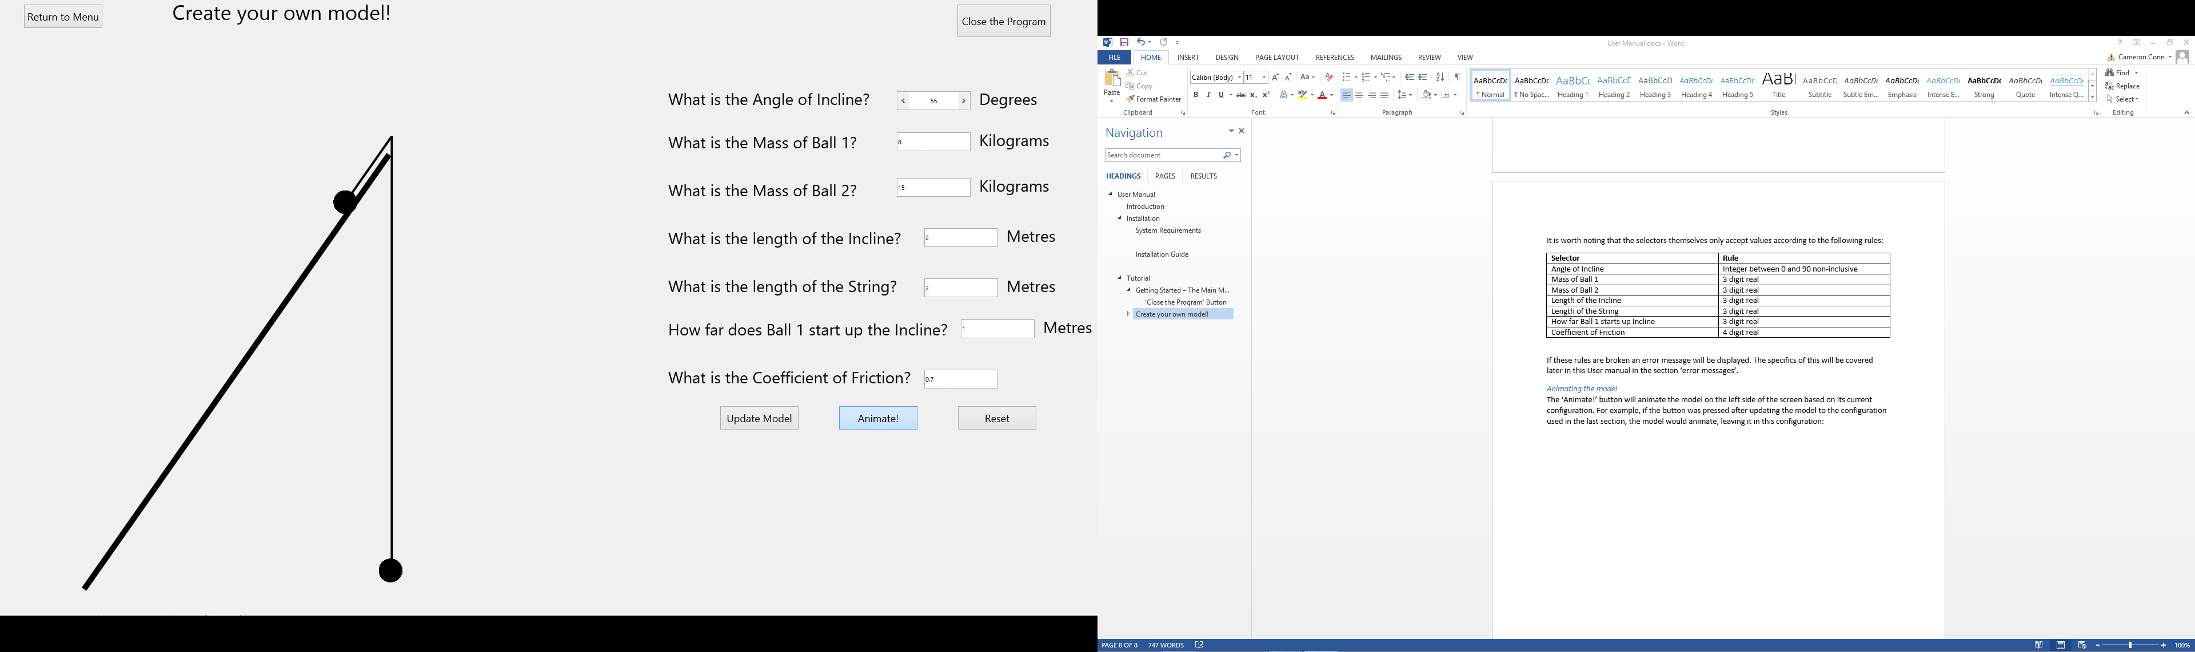

This occurred because Ball 2 was heavy enough to pull Ball 1 up the slope, despite any resistive forces. In some configurations Ball 1 will roll down the slope, pulling Ball 2 upwards. However, in other configurations, the values will be such that the balls do not move. If this occurs, a message is displayed explaining why this is. For example, if the configuration is changed so it is as below:

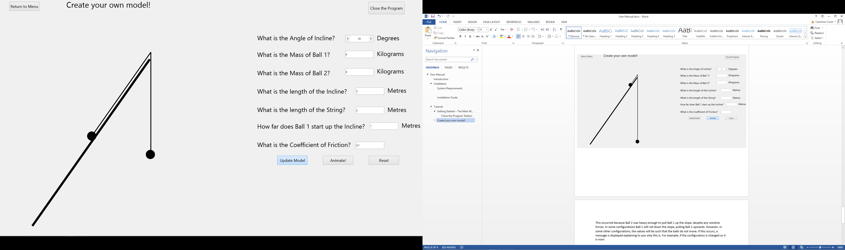

This value has changed

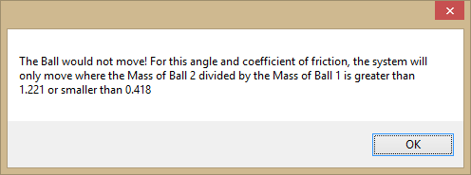And the ‘Animate!’ button is selected, no animation occurs and this message is displayed:

This informs why no animation occurred and implies what could be changed to make the system animate.

#### Resetting the model

The ‘Reset’ button resets the configuration and the model to default values. For example, if the configuration and model were setup as below:

And then the ‘Reset’ button was pressed, the system would reset to:

Note that this is the same configuration the form is found in when it is originally opened.

### Practice!

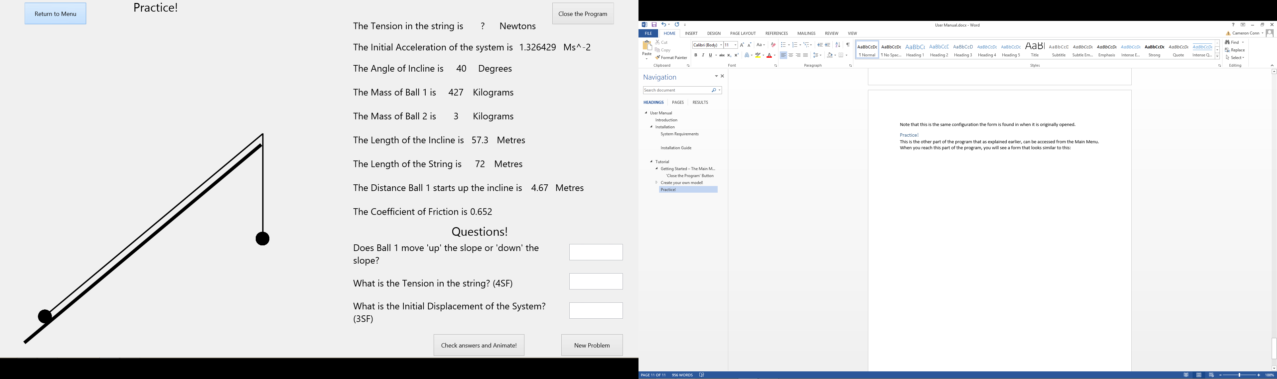This is the second part of the program which can be accessed from the Main Menu. It initially displays a form as below:

When the form is opened, a random M1 pulley systems on an incline problem is created. The values for which are displayed on the right side of the screen:



Any values that are ‘?’ are values to be questoined on. The questions appear below the information:

The first question always is whether Ball 1 moves up or down the slope. The other two questions either ask you to calculate values marked ‘?’ or another variable that can be calculated from the given information (Such as ‘initial displacement’). All the answers can be calculated using M1 equations for pulley systems on an incline. Answers to the questions should be entered into the adjacent text-boxes:

Text-boxes



The functionality of the buttons on this form are four fold:

#### Returning to the Menu

To return to the Main Menu, select the ‘Return to Menu’ button.

#### Close the Program

To close the program, select the ‘Close the program’ button.

#### Check answers and Animate!

When this button is selected, the answers will be compared against the correct answers. If any of the answers are incorrect, a message that looks like this will be displayed:

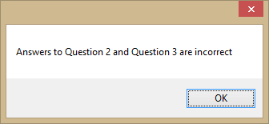

This message will change based on what questions are wrong.

However, if all answers are correct, this message will be displayed:

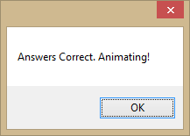

When this message is closed, the model on the left side of the screen will animate based on the configuration. In the example used above (included again here):

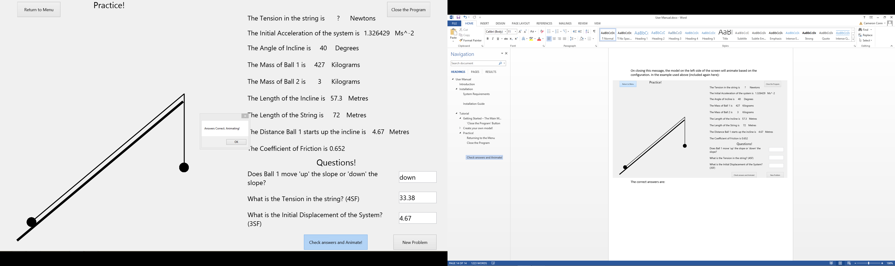The correct answers are:

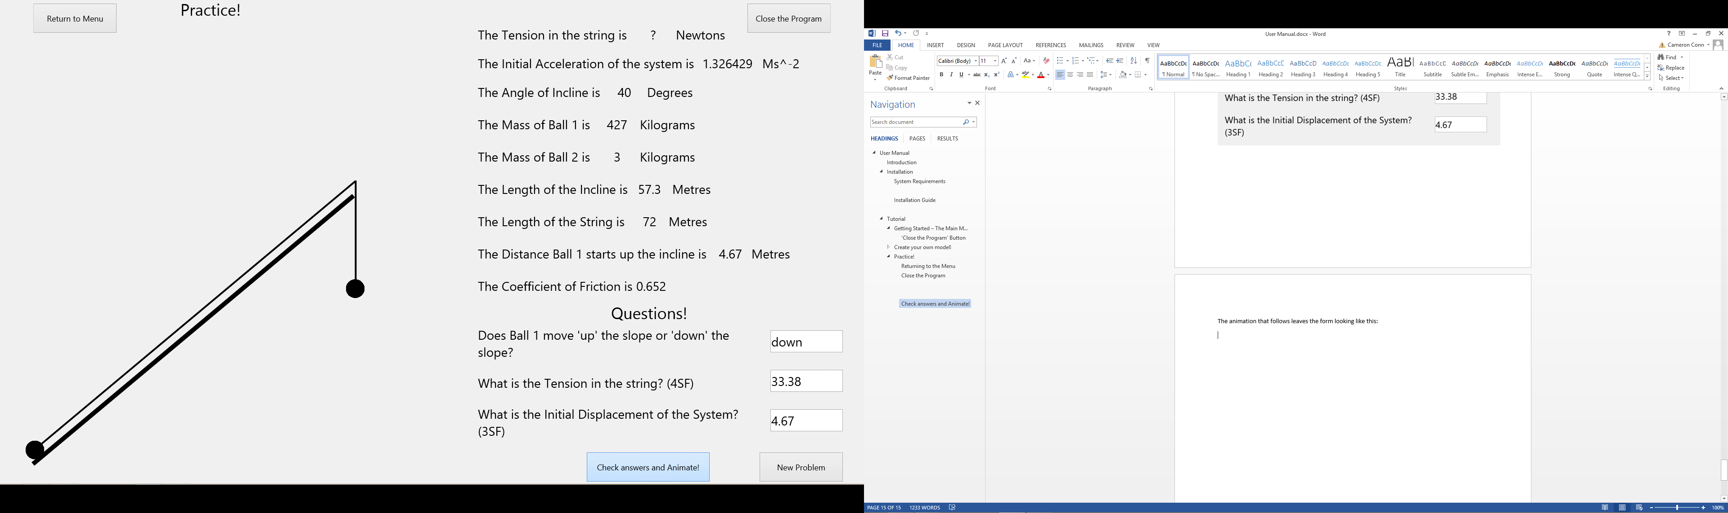The animation that follows leaves the form looking like this:

#### New Problem

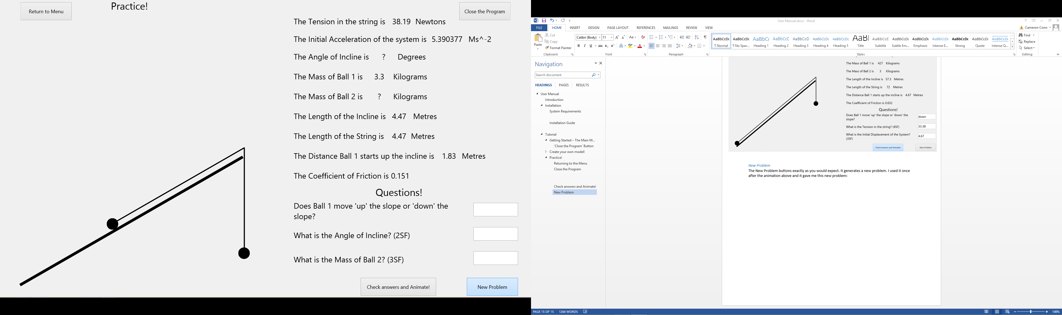The New Problem button generates a new problem, For example:

## Error Messages

#### The Main Menu

There are no error messages that can appear on this form.

#### Create your own Problem!

On this form, the user can encounter errors if the user’s inputs don’t follow these rules:

|  |  |
| --- | --- |
| **Selector** | **Rule** |
| Angle of Incline | Integer between 0 and 90 non-inclusive |
| Mass of Ball 1 | 3 digit or less real |
| Mass of Ball 2 | 3 digit or less real |
| Length of the Incline | 3 digit or less real |
| Length of the String | 3 digit or less real |
| How far Ball 1 starts up Incline | 3 digit or less real |
| Coefficient of Friction | 4 digit or less real |

If any of these rules are broken, a corresponding error message will be shown:

##### Angle of Incline

##### Mass of Ball 1

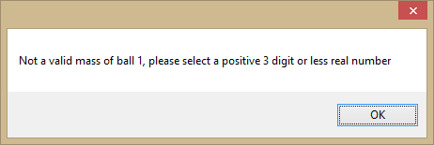

##### Mass of Ball 2

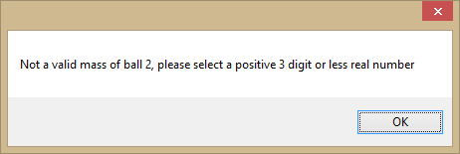

##### Length of Incline

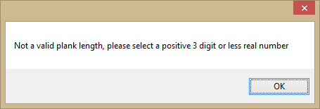

##### Length of String

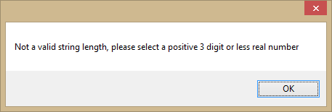

##### Distance Ball 1 up Incline

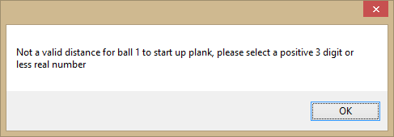

##### Coefficient of Friction

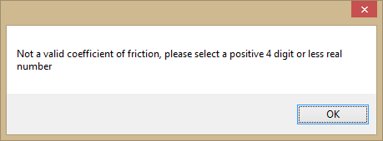

To recover from these error messages, select OK. This will reset the value you changed to its default value.

There are also other error messages. If the model the user tries to create is not within the bounds of the M1 specification, an error message corresponding to the validation check it failed is displayed:

##### Distance Ball 1 starts up the Plank < Length of the Plank

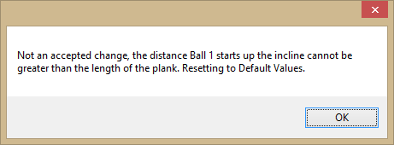

##### Distance Ball 1 starts up the Plank + Length of the String > Length of the Plank

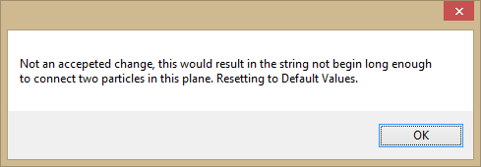

##### (Length of the Plank * Sin(Plank Angle)) – Length of the String + Length of the Plank – Distance Ball 1 starts up the Plank > 0

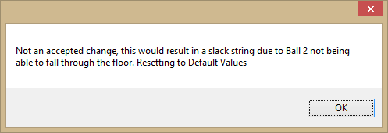

To recover from the three error messages above, select OK. This resets the model to default values.

These error message depend on which way Ball 1 is moving. Note that Extra Displacement is the additional displacement one of the Balls undergoes after the model passes the equilibrium position for the first time:

##### If Ball 1 moving up the slope: (Length of the Plank * Sin(Plank Angle)) – Length of the String + Extra Displacement < 0

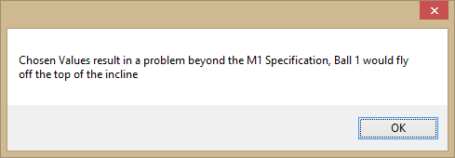

##### If Ball 1 moving down the slope: Length of the Plank – Length of the String + Extra Displacement < 0

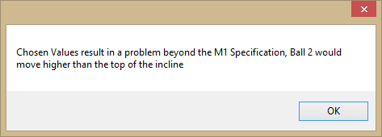

To recover from these error messages, select OK. No animation will occur, and the user will be able to change your values to make the model M1 standard.

#### Practice!

No error messages can occur on this form.